Step 1: Create a APS.NET CORE Web App (Model-View-Controller) – Give the Name CoreWebApp

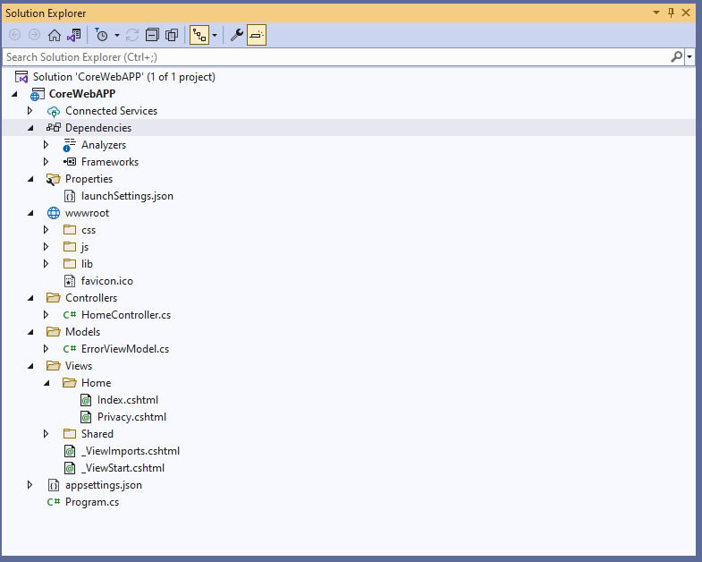

Step2: Add Needed Packages by using NuGet Package Manager

* Microsoft.EntityFrameworkCore
* Microsoft.EntityFrameworkCore.SqlServer
* Microsoft.EntityFrameworkCore.Tools
* Microsoft.EntityFrameworkCore.Design
* Microsoft.VisualStudio.Web.CodeGeneration.Design

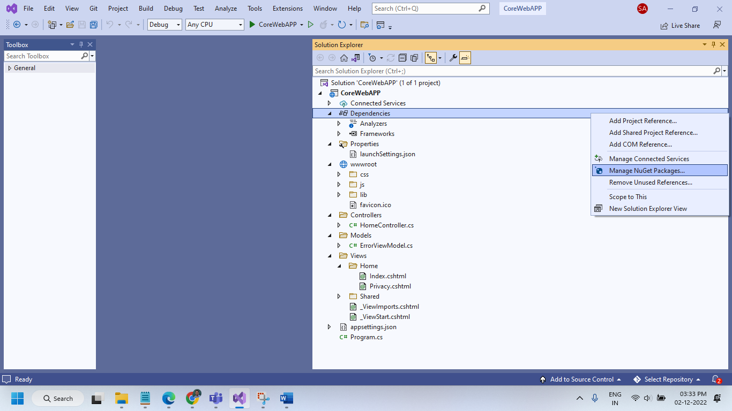

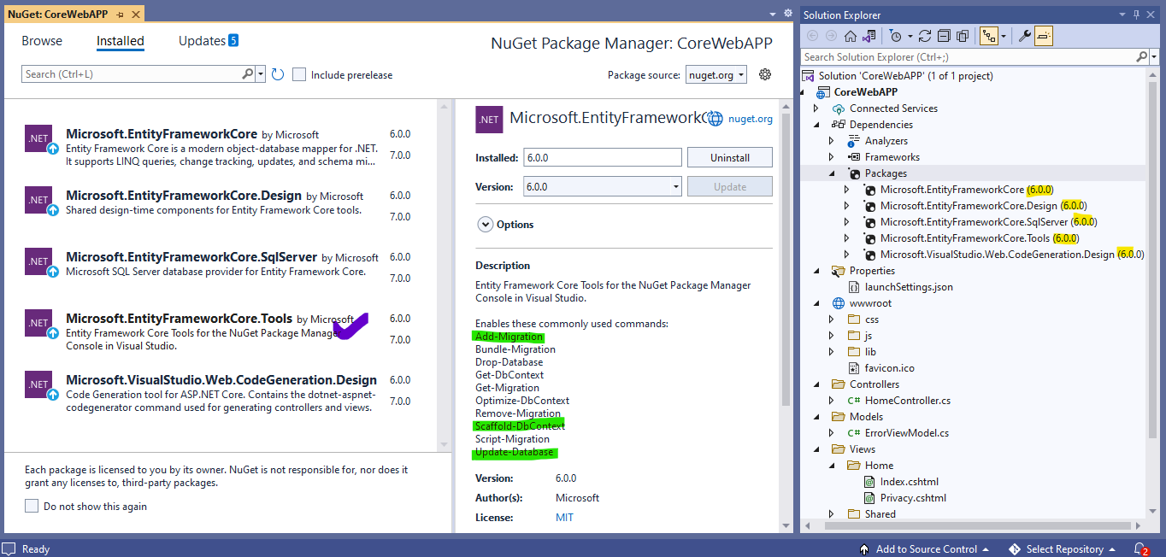

Step 3: Add a **Connection String** to our SQL Server in **appsetttings.json** configuration file

{

"Logging": {

"LogLevel": {

"Default": "Information",

"Microsoft.AspNetCore": "Warning"

}

},

"AllowedHosts": "*",

"ConnectionStrings": {

"MyConStr": "Data Source=SYED22\\SQLEXPRESS;Initial Catalog=CSDCoreDB;Integrated Security=True;"

}

}

Step 4: Define a model in Models Folder

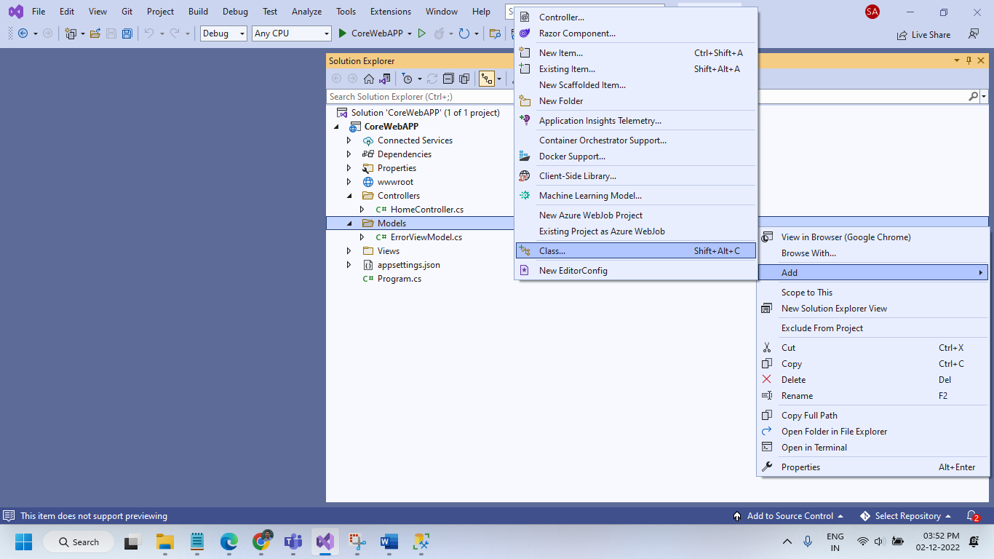

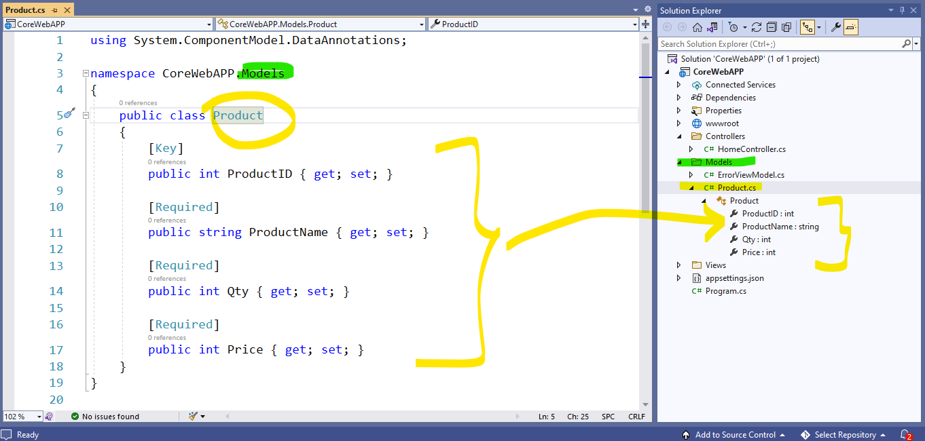

Step 5: Add AppDBContext class for our application in Models Folder (Going to take care of DB Trans)

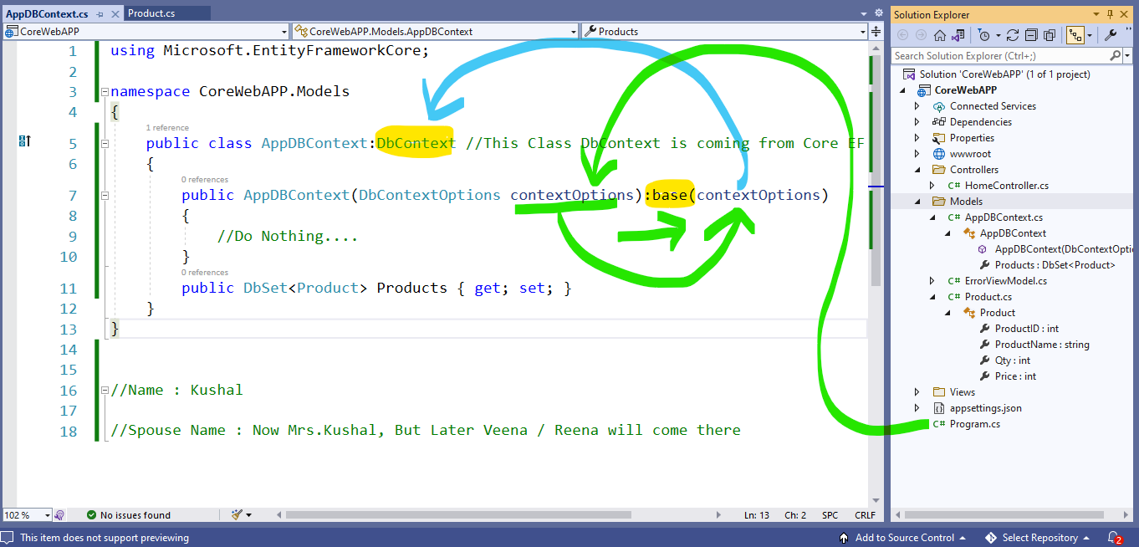

Actually here we are going to dependency injection (SOLID Principles)

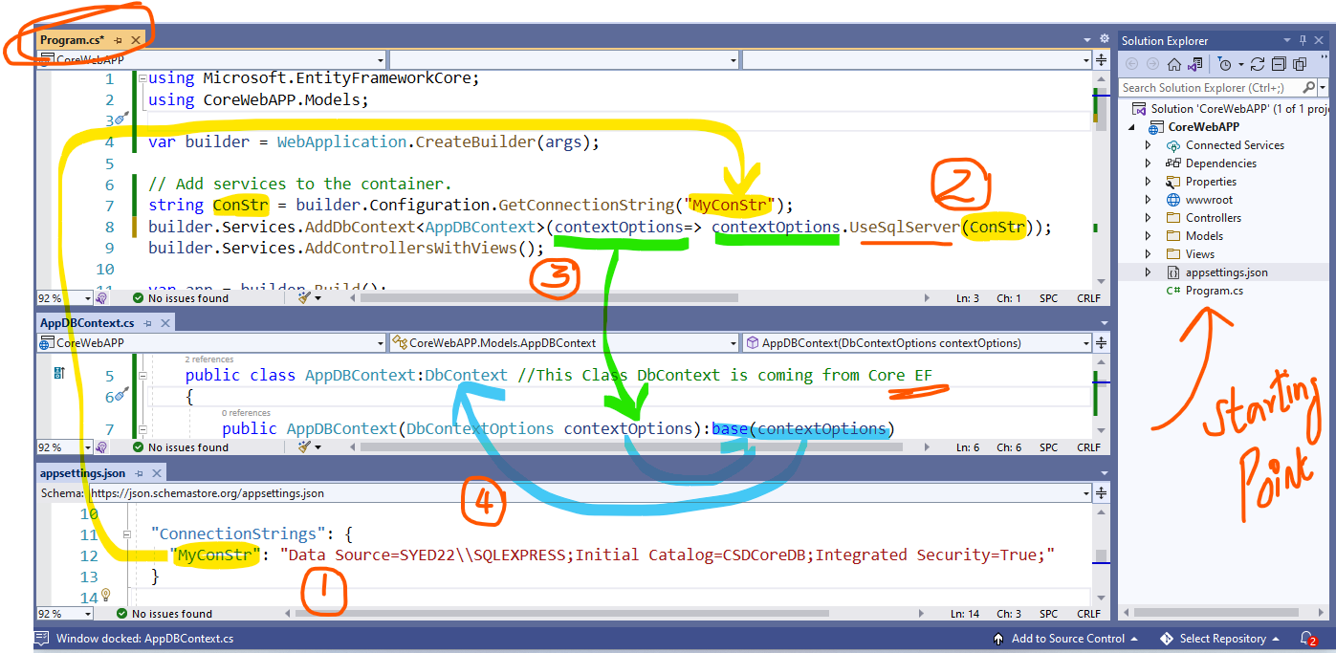

Step 6: Run Migration Commands in PMC

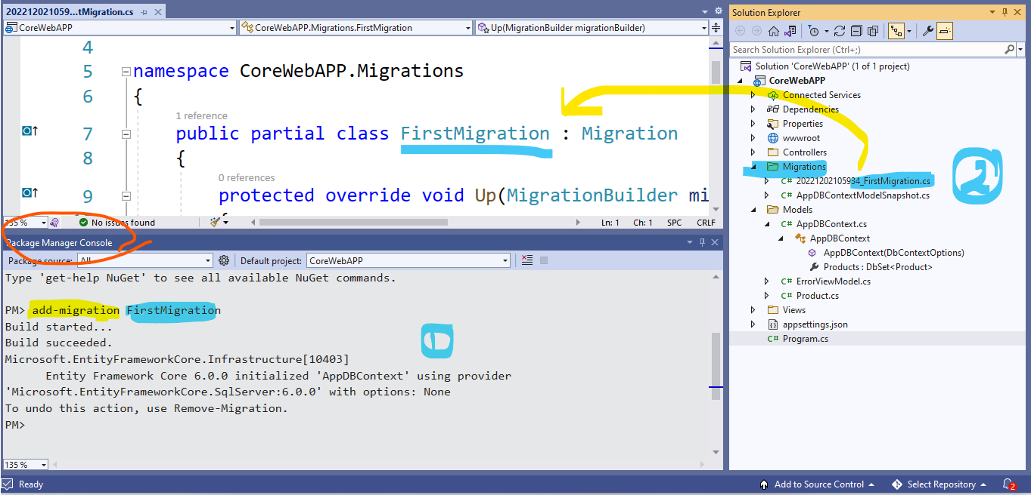

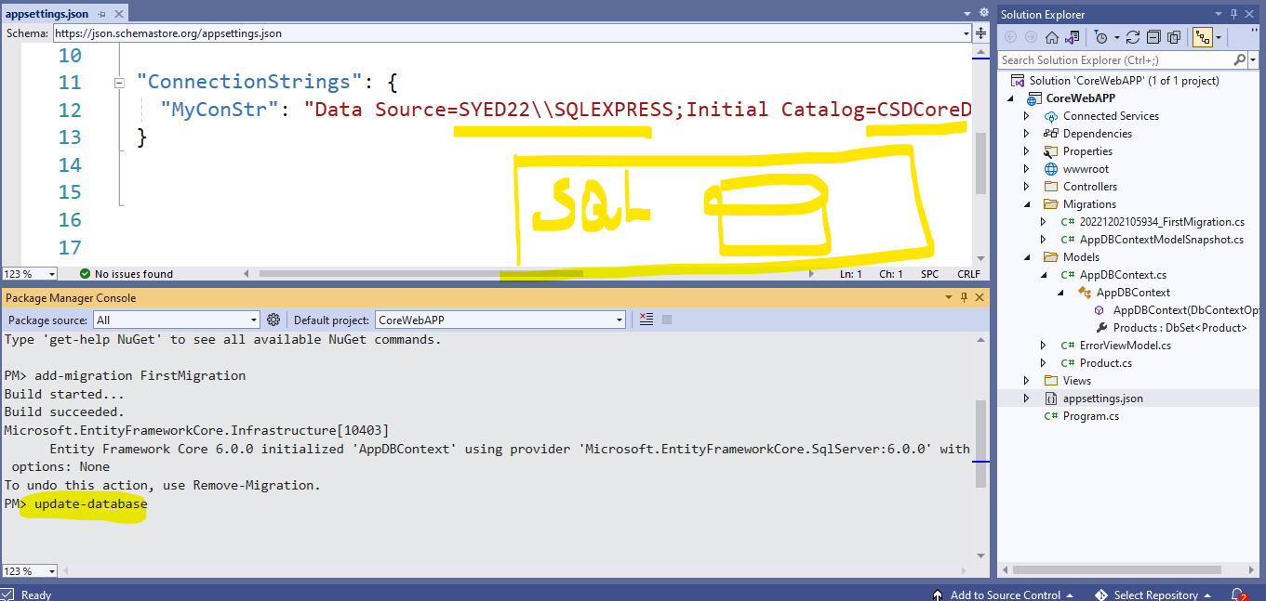

Step 8: Add a controller using Entity Framework

